**OCI Document Understanding**

**TEXT EXTRACTION**

**Configure OCI API Keys and a Bucket**

* **Generate API Keys using OCI Console**

1. Login into your OCI Account.
2. Navigate to Identity & Security > Domains > ‘User Management’ tab > Click on username.

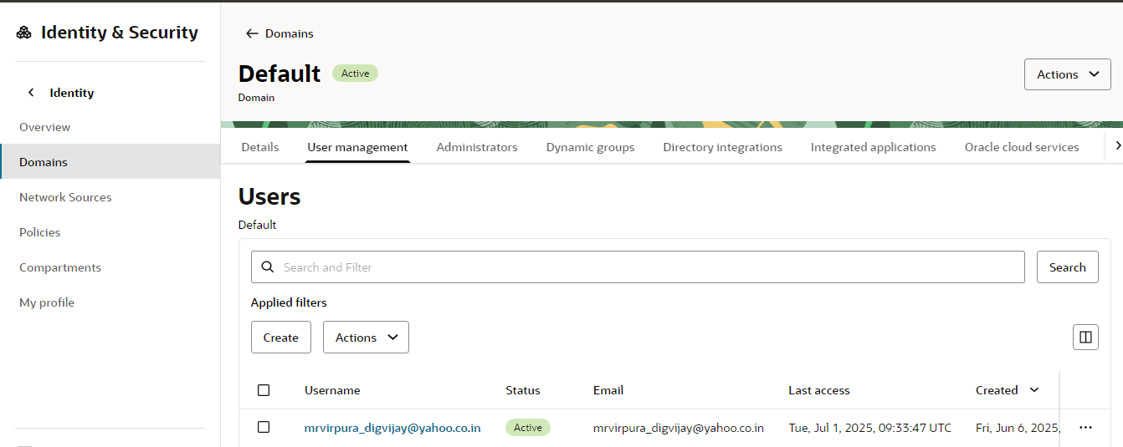

1. Under User > ‘API Keys’ tab, click **Add API Key**.

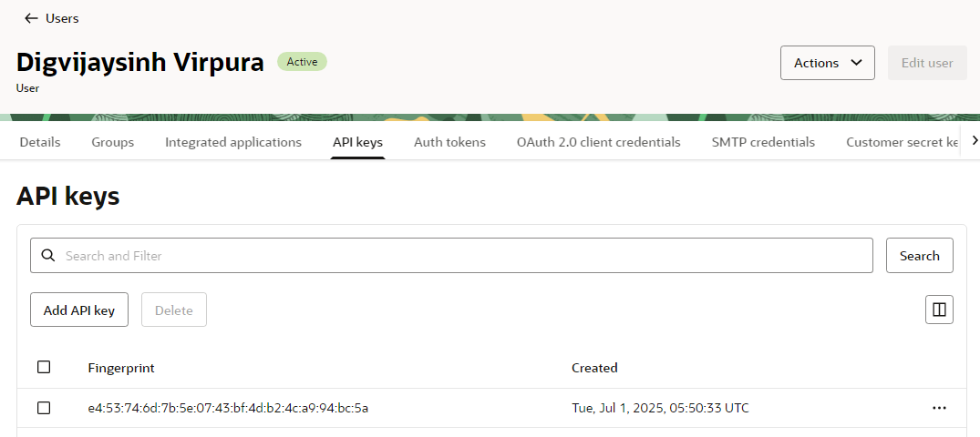

1. The Add API Key dialog is displayed. Select **Generate API Key Pair** to create a new key pair.
2. Click **Download Private Key**. A .pem file is saved to your local device. You do not need to download the public key. Click **Add**.
3. The key is added, and the Configuration File Preview is displayed. Copy and save the configuration file snippet from the text box into a notepad. You will use this information for creating Oracle APEX Web Credentials.

* **Create a Bucket in OCI Object Storage**

1. To access the Object Storage service, click on the menu icon **(☰)** at the top-left corner.
2. Under Storage, select **Buckets**.
3. Select the compartment where you want to create the Bucket. You can choose an existing compartment or create a new one if needed. Now, select **Create Bucket**.

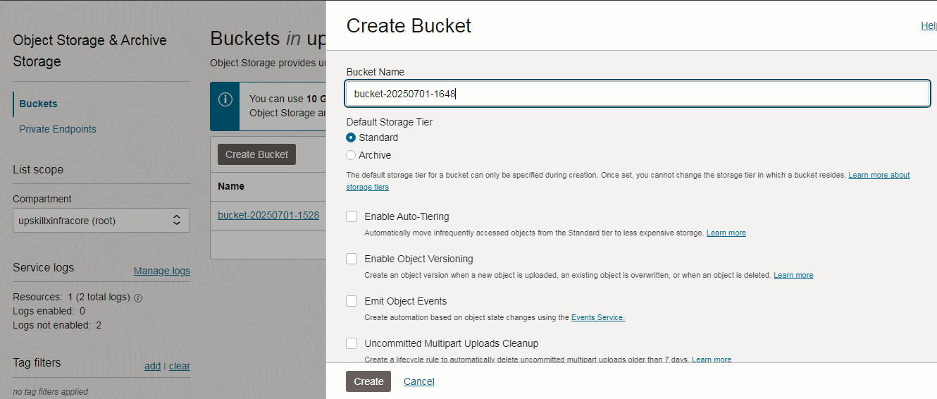

1. Provide bucket name and copy and save **Bucket Name** and **Namespace** from the bucket details into a notepad. You will use this information to upload an invoice to OCI Object Storage using Invoke API.

* **Create Web Credentials in Oracle APEX**

1. Workspace Utilities > Web Credentials > Create new Credentials
   1. Authentication Type = OCI Native Authentication
   2. OCI User ID = Provide OCI ID (Go to My Profile in OCI and copy "OCID")
   3. OCI Tenancy ID = Provide Tenancy ID (Go to tenancy and copy Tenancy ID)
   4. OCI Public Fingerprint = Go to My Profile > Scroll down and find "API Key

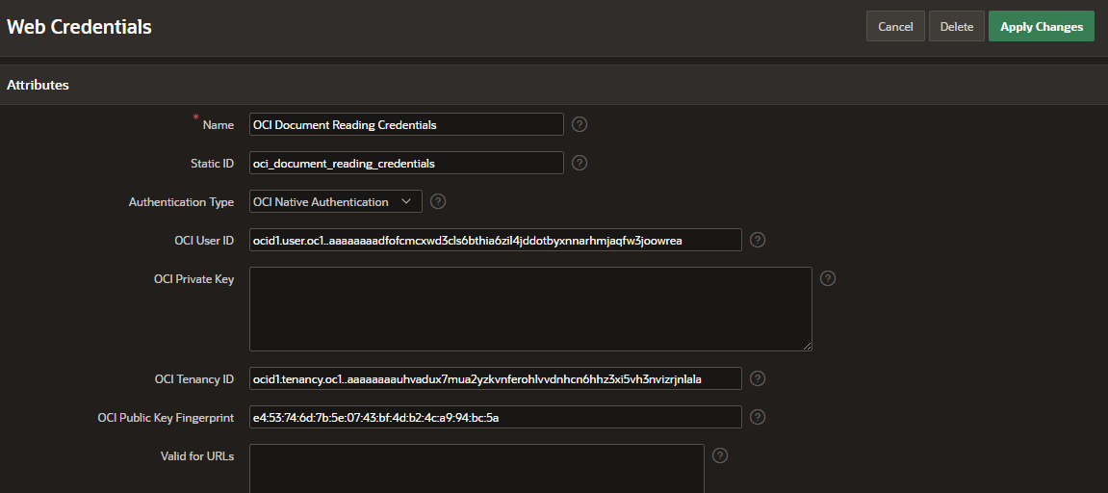

1. Click Create.

**Create Rest Data Source:**

* **Invoke OCI Doc Understanding using REST Data Source**

1. Navigate to the application home page and click **Shared Components**.
2. Under Data Sources, click **REST Data Sources**.
3. Click **Create** > **From scratch** and click **Next**.
4. Under Create REST Data Source, enter the following attributes and click **Next**.
   * **Rest Data Source Type**: Oracle Cloud Infrastructure (OCI)
   * **Name**: OCI Document Understanding API
   * **URL Endpoint:** <https://document.aiservice.ap-mumbai-1.oci.oraclecloud.com>/20221109/actions/analyzeDocument

**Note**: URL Endpoint may differ based on your OCI tenancy.

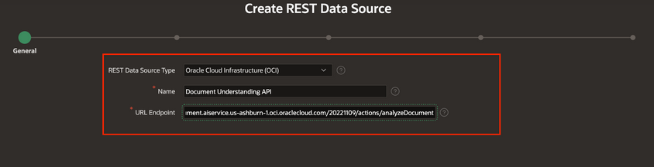

1. Under create REST Data Source - Remote Server, click **Next**.
2. Under Authentication,
   * **Authentication Required**: Toggle the button to **ON**
   * **Credentials**: apex_ai_cred
3. Click **Create REST Source Manually**. The REST data source is created successfully. The next step is to configure the POST operation parameters for this REST Data Source.
4. On the REST Data Sources page, click **Document Understanding API**.
5. Under the **Operations**, click **Edit icon** for the **POST** operation and enter the following:
   * Request Body Template: Copy and paste the JSON given below.

{

"compartmentId" : "#COMPARTMENT_ID#",

"document" :

{

"namespaceName" : "#NAMESPACE_NAME#",

"bucketName" : "#BUCKET_NAME#",

"objectName" : "#OBJECT_NAME#",

"source" : "OBJECT_STORAGE"

},

"features" :

[

{

"featureType" : "#FEATURE_TYPE#"

}

]

}

1. Click **Synchronize with Body** and then click **OK**.

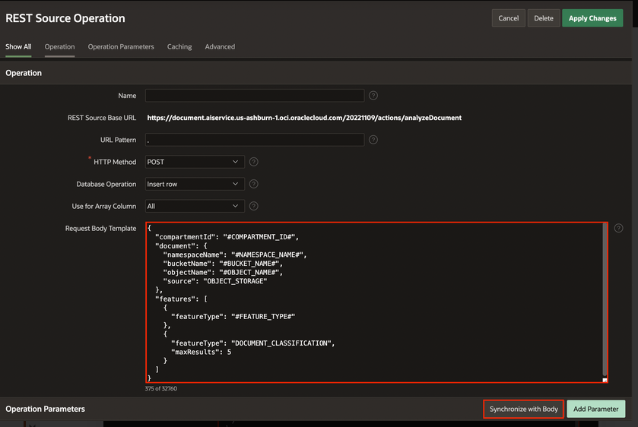

1. Under **Operation Parameters**, click **Add Parameter**.
2. In the **Edit REST Data Source Parameter** dialog, add the following two parameters one after the other:

| **Type** | **Name** | **Direction** | **Default Value** | **Static** |
| --- | --- | --- | --- | --- |
| HTTP Header | Content-Type | In | application/json | ON |
| Request or Response Body | RESPONSE | Out |  |  |

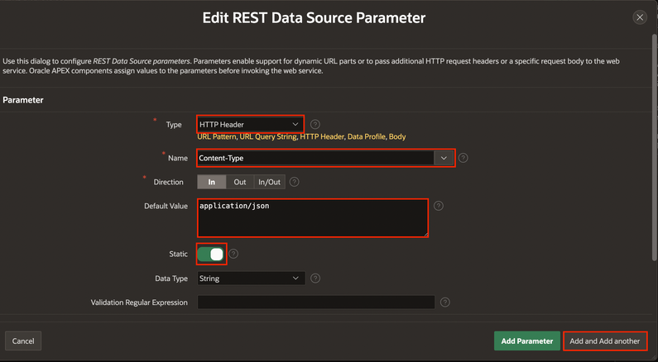

1. Click **Apply Changes**.
2. Create an application with following page items.

| **Identification > Name** | **Identification > Type** | **Default > Type** | **Default > Static** | **Session State > Datatype** |
| --- | --- | --- | --- | --- |
| **P1_FILE_BLOB** | **File Upload** |  |  |  |
| P1_COMPARTMENT_ID | Hidden | Static | Enter your OCI account Compartment ID |  |
| P1_CRED_STATIC_ID | Hidden | Static | oci_oacupx_document_reading |  |
| P1_NAMESPACE_NAME | Hidden | Static | Enter Namespace which you copied while creating a Bucket |  |
| P1_BUCKET_NAME | Hidden | Static | Enter the Bucket Name which you copied while creating a Bucket |  |
| P1_FEATURE_TYPE | Hidden | Static | TEXT_EXTRACTION |  |
| P1_REGION | Hidden | Static | ap-mumbai-1 |  |
| P1_RESPONSE | Hidden |  |  | CLOB |

1. In the property editor, Enter/select the following details:
   * Under Identification:
     + Button Name: **Process_Document**
     + Label: **Process Document**
   * Layout > Slot: **Create**
   * Behavior > Database Action: **SQL INSERT action**

**Create Processes to upload Invoices to Object:**

1. Right-click **Process Invoice** and select **Add Child Process**.
2. In the Property Editor, Enter/select the following details:
   * Under Identification:
     + Name: **Upload to Object Storage**
     + Type: **Invoke API**
   * Under Settings:
     + Type: **PL/SQL Procedure or Function**
     + Procedure or Function: **UPLOAD_FILE**

**Procedure:**

**======== =================UPLOAD_FILE============================**

CREATE OR REPLACE PROCEDURE UPLOAD_FILE (

P_FILE_CONTENT IN VARCHAR2,

P_STATIC_ID IN VARCHAR2,

P_NAMESPACE IN VARCHAR2,

P_BUCKET IN VARCHAR2,

P_REGION IN VARCHAR2,

P_OBJECT_STORAGE_URL OUT VARCHAR2,

P_FILE_NAME OUT VARCHAR2,

P_MIME_TYPE OUT VARCHAR2

) IS

L_OBJECT BLOB;

L_RESPONSE CLOB;

BEGIN

SELECT

BLOB_CONTENT,

FILENAME,

MIME_TYPE

INTO

L_OBJECT,

P_FILE_NAME,

P_MIME_TYPE

FROM

APEX_APPLICATION_TEMP_FILES

WHERE

NAME = P_FILE_CONTENT;

P_OBJECT_STORAGE_URL := 'https://objectstorage.'

|| P_REGION

|| '.oraclecloud.com/n/'

|| P_NAMESPACE

|| '/b/'

|| P_BUCKET

|| '/o/'

|| P_FILE_NAME;

APEX_WEB_SERVICE.G_REQUEST_HEADERS(1).NAME := 'Content-Type';

APEX_WEB_SERVICE.G_REQUEST_HEADERS(1).VALUE := P_MIME_TYPE;

L_RESPONSE := APEX_WEB_SERVICE.MAKE_REST_REQUEST(P_URL => P_OBJECT_STORAGE_URL, P_HTTP_METHOD => 'PUT', P_BODY_BLOB => L_OBJECT, P_CREDENTIAL_STATIC_ID => P_STATIC_ID

);

IF APEX_WEB_SERVICE.G_STATUS_CODE != 200 THEN

RAISE_APPLICATION_ERROR(-20000, 'Upload failed - ' || APEX_WEB_SERVICE.G_STATUS_CODE);

END IF;

END UPLOAD_FILE;

========================================================================

1. Under **Upload to Object Storage** process, expand Parameters and enter the following details:

| **Parameters** | **Value > Type** | **Value > Item** |
| --- | --- | --- |
| p_file_content | item | P1_FILE_BLOB |
| p_static_id | item | P1_CRED_STATIC_ID |
| p_namespace | item | P1_NAMESPACE_NAME |
| p_bucket | item | P1_BUCKET_NAME |
| p_region | item | P1_REGION |

1. Right-click **Process Invoice** and select **Add Child Process**.
2. In the Property Editor, Enter/select the following details:
   * Under Identification:
     + Name: **Automatic DML**
     + Type: **Form - Automatic Row Processing (DML)**
     + Form Region: **Upload Your Invoice**
3. Right-click **Process Invoice** and select **Add Child Process**.
4. In the Property Editor, Enter/select the following details:
   * Under Identification:
     + Name: **Integrate Document Understanding API**
     + Type: **Invoke API**
   * Under Settings:
     + Type: **REST Source**
     + REST Source: **Document Understanding API**
     + Operation: **POST**
5. Under **Integrate Document Understanding API** process, expand Parameters and select **OBJECT_NAME**, enter the following:
6. Under Value:
   * Type: **Item**
   * Item: **P1_FILE_NAME**
7. Select **RESPONSE**, Enter/select the following:

* Parameter > Ignore Output: **Toggle off**
* Value > Item: **P1_RESPONSE**
* **Session State > Datatype : CLOB**

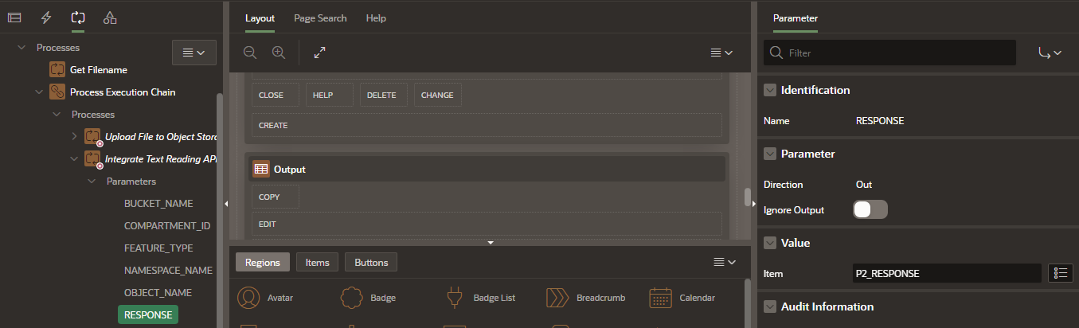

1. Create one Classic Report Region for displaying received Response with below query:

SELECT jt.text FROM

JSON_TABLE(

:P2_RESPONSE, '$.pages[*].words[*]'

COLUMNS (text VARCHAR2(4000) PATH '$.text')

) jt

1. Run the application. Upload a file and check for output in report.

**KEY VALUE EXTRACTION**

1. Follow all the above steps.
2. Set the F1_FEATURE_TYPE page item with below mentioned value:

| **Identification > Name** | **Identification > Type** | **Default > Type** | **Default > Static** | **Session State > Datatype** |
| --- | --- | --- | --- | --- |
| P1_FEATURE_TYPE | Hidden | Static | KEY_VALUE_EXTRACTION |  |

1. Create a table **DOCAI_RESPONSE** as shown below:

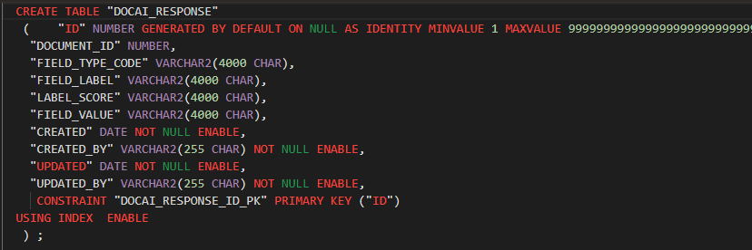

1. Create one Child Process: **‘Parse Response’** in Process Execution Chain to parse the response and store in a DOCAI_RESPONSE table.

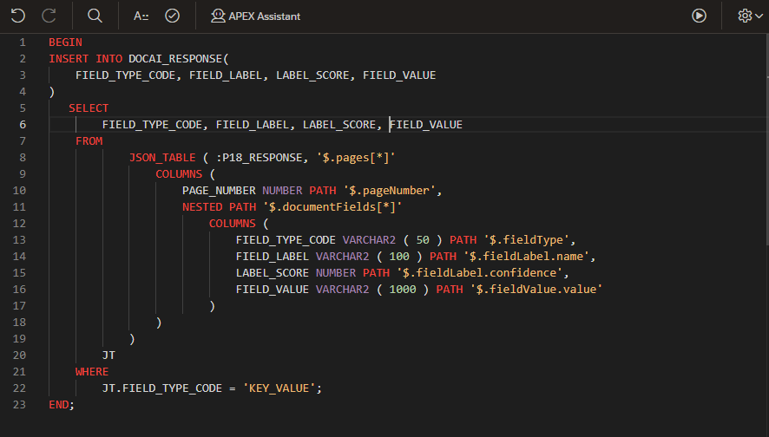

1. Create a Classic Report Region with below query to display parsed data in proper format.

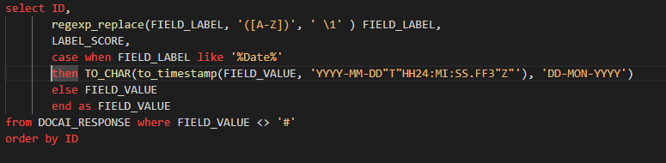

1. Run the application and upload any invoice or receipt and observe the output with key value fields.

Input Image:

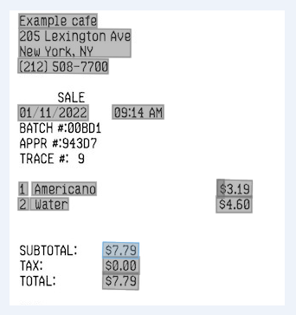

Output:

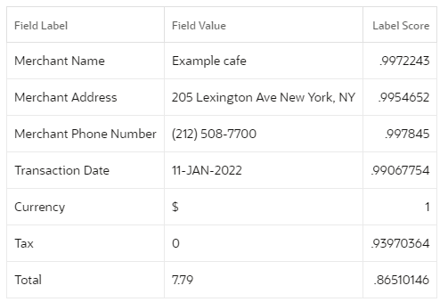

**OCI Vision**

**IMAGE CLASSIFICATION**

Follow **Configure OCI API Keys and a Bucket** Step from Pg 1

**Create Rest Data Source:**

* **Invoke OCI Doc Understanding using REST Data Source**

1. Navigate to the application home page and click **Shared Components**.
2. Under Data Sources, click **REST Data Sources**.
3. Click **Create** > **From scratch** and click **Next**.
4. Under Create REST Data Source, enter the following attributes and click **Next**.
   * **Rest Data Source Type**: Oracle Cloud Infrastructure (OCI)
   * **Name**: OCI Vision
   * **URL Endpoint**<https://vision.aiservice.ap-mumbai-1.oci.oraclecloud.com>/20221109/actions/analyzeImage
   * **Note**: URL Endpoint may differ based on your OCI tenancy.

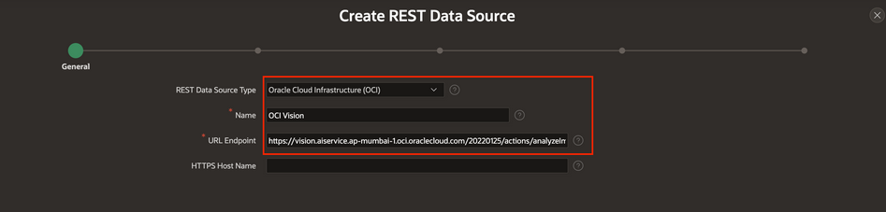

1. Under create REST Data Source - Remote Server, click **Next**.
2. Under Authentication,
   1. **Authentication Required**: Toggle the button to **ON**
   2. **Credentials**: apex_ai_cred
3. Click **Create REST Source Manually**. The REST data source is created successfully. The next step is to configure the POST operation parameters for this REST Data Source.
4. On the REST Data Sources page, click **Document Understanding API**.
5. Under the **Operations**, click **Edit icon** for the **POST** operation and enter the following:
   1. Request Body Template: Copy and paste the JSON given below.

{

"compartmentId" : "#COMPARTMENT_ID#",

"image" :

{

"namespaceName" : "#NAMESPACE_NAME#",

"bucketName" : "#BUCKET_NAME#",

"objectName" : "#OBJECT_NAME#",

"source" : "OBJECT_STORAGE"

},

"features" :

[

{

"featureType" : "#FEATURE_TYPE#"

}

]

}

1. Click **Synchronize with Body** and then click **OK**.



1. Under **Operation Parameters**, click **Add Parameter**.
2. In the **Edit REST Data Source Parameter** dialog, add the following two parameters one after the other:

| **Type** | **Name** | **Direction** | **Default Value** | **Static** |
| --- | --- | --- | --- | --- |
| HTTP Header | Content-Type | In | application/json | ON |
| Request or Response Body | RESPONSE | Out |  |  |



1. Click **Apply Changes**.
2. Follow from Step 14 of (Create REST Source from Document Understanding) to create application and its processes.
3. Replace Rest Source with the one created above for OCI Vision.
4. Create a Classic Report Region with below query:

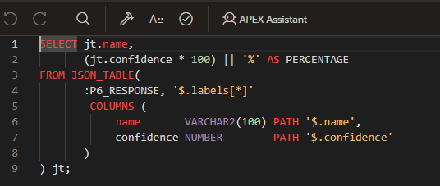

1. Run the application and upload the image.

Input Image:



Output:

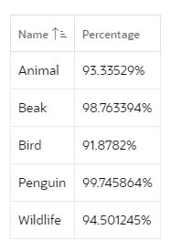

**OBJECT DETECTION**

1. Follow all the above steps of OCI Vision Image Classification.
2. Set the F1_FEATURE_TYPE page item with below mentioned value:

| **Identification > Name** | **Identification > Type** | **Default > Type** | **Default > Static** | **Session State > Datatype** |
| --- | --- | --- | --- | --- |
| P1_FEATURE_TYPE | Hidden | Static | OBJECT_DETECTION |  |

1. Create a Classic Report Region with below query:

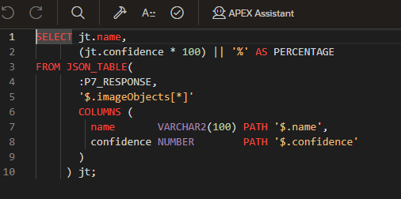

1. Run the application and upload the image and observe the output.

Input Image



Output

